**Finding the best place to open an Italian restaurant in Moscow**

Victor A.

30 June 2020

1. Introduction: Business Problem

In this project we will try to find an optimal location for a restaurant. Specifically, this report will be targeted to stakeholders interested in opening an Italian restaurant in Moscow, Russia.

Since there are lots of restaurants in Moscow we will try to detect locations that are not already crowded with restaurants. We are also particularly interested in areas with no Italian restaurants in vicinity. We would also prefer locations as close to city center as possible, assuming that first two conditions are met.

We will use our data science powers to generate a few most promising neighborhoods based on this criterion. Advantages of each area will then be clearly expressed so that best possible final location can be chosen by stakeholders.

1. Data

Based on definition of our problem, factors that will influence our decision are:

* number of existing restaurants in the neighborhood (any type of restaurant)
* number of and distance to Italian restaurants in the neighborhood, if any
* distance of neighborhood from city center

We decided to use regularly spaced grid of locations, centered around city center, to define our neighborhoods.

Following data sources will be needed to extract/generate the required information:

* enters of candidate areas will be generated algorithmically and approximate addresses of centers of those areas will be obtained using Google Maps API reverse geocoding
* number of restaurants and their type and location in every neighborhood will be obtained using Foursquare API
* coordinate of Moscow center will be obtained using Google Maps API geocoding of well-known Moscow location (Kremlin)

1. Methodology

In this project we will direct our efforts on detecting areas of Moscow that have low restaurant density, particularly those with low number of Italian restaurants. We will limit our analysis to area ~6km around city center.

In first step we have collected the required data: location and type (category) of every restaurant within 6km from Moscow center (Kremlin). We have also identified Italian restaurants (according to Foursquare categorization).

Second step in our analysis will be calculation and exploration of restaurant density across different areas of Moscow - we will use heatmaps to identify a few promising areas close to center with low number of restaurants in general (and no Italian restaurants in vicinity) and focus our attention on those areas.

In third and final step we will focus on most promising areas and within those create clusters of locations that meet some basic requirements established in discussion with stakeholders: we will take into consideration locations with no more than two restaurants in radius of 250 meters, and we want locations without Italian restaurants in radius of 400 meters. We will present map of all such locations but also create clusters (using k-means clustering) of those locations to identify general zones / neighborhoods / addresses which should be a starting point for final 'street level' exploration and search for optimal venue location by stakeholders.

1. Analysis

Density of restaurants in Moscow center presented in Figure 1.

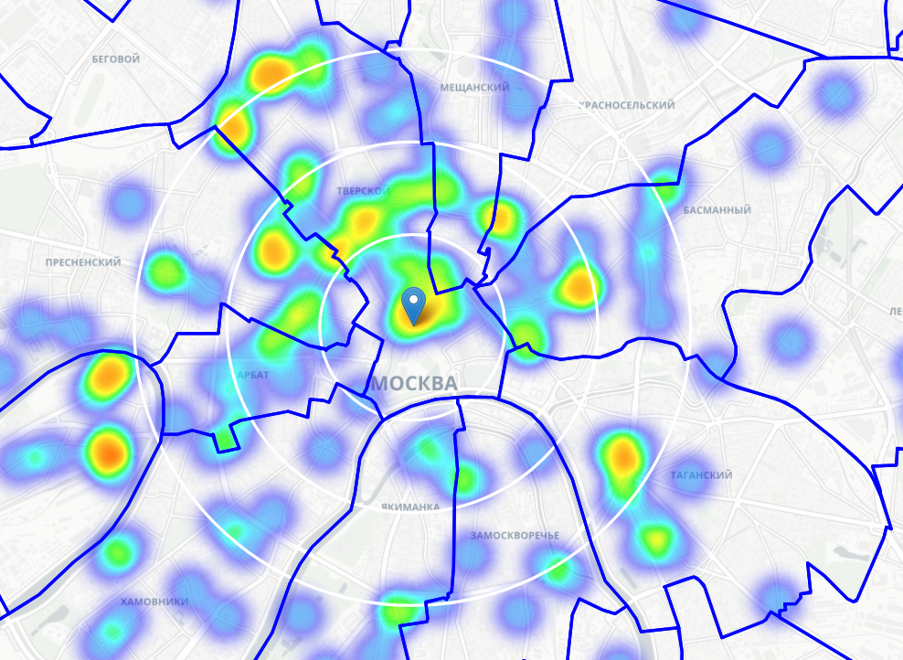

**R = 3km**

**R = 2km**

**R = 1km**

Figure 1. Density of restaurants in Moscow center

Based on Figure 1 we move the center of our area of interest and reduce it's size to have a radius of 2.5km. This places our location candidates mostly in boroughs Hamovniki, Yakimanka, Zamoskvoreche and Taganskiy.

Locations that has no more than two restaurants in radius of 250m, and no Italian restaurant closer than 400m is a potential candidate for a new Italian restaurant. Heatmap with such locations is presented in Figure 2.

Cluster analysis was done to find centers of zones containing good locations. Clusters of good locations presented in Figure 3.

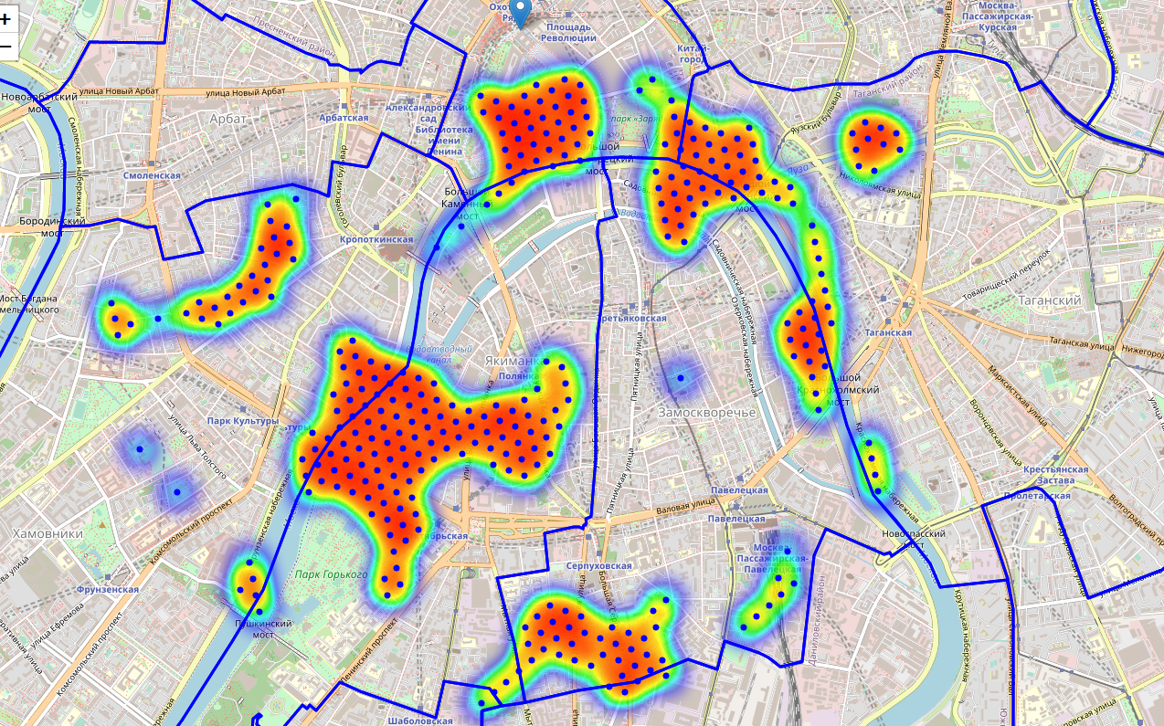

Figure 2 Locations with no more than two restaurants in radius of 250 meters, and no Italian restaurants in radius of 400 meters

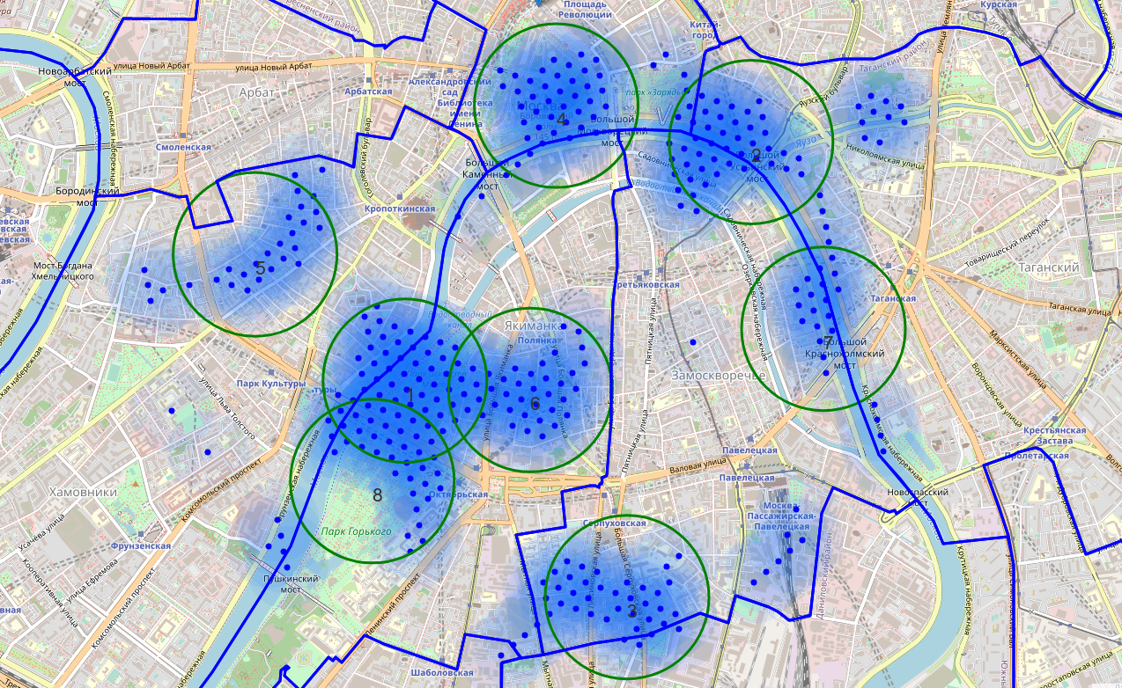

Figure 3 Clusters of good locations

List of found clusters:

* + **area 1**: Krymskaya nab., 16 building 1, Moscow, 119049 => 2.5km from Kremlin

(*Surroundings of the Museum and Exhibition Center State Tretyakov Gallery on Krymsky Val*)

* + **area 2**: Moskvoretskaya Embankment, 7, стр.1, Moscow, 109240 => 1.6km from Kremlin

(*Landmark Imperial educational house and part of Moskvoretskaya embankment with a pier*)

* + **area 3:** Bolshaya Serpukhovskaya, house 40, building 2, Moscow,115093 => 3.7km from Kremlin

(*Mostly residential area next to the children's hospital*)

* + **area 4**: Kremlin
  + **area 5**: Malyy Levshinskiy Pereulok, 14/9 строение 1, Moscow, 119034 => 2.4km from Kremlin

(*Prechistenka Street (right side) mostly business area*)

* + **area 6**: Ulitsa Malaya Polyanka, 8, Moscow, 119180 => 2.4km from Kremlin

(*1st Khvostov lane mostly buiseness area near French embassy*)

* + **area 7**: Kosmodamianskaya Naberezhnaya, 38 строение 2, Moscow, 115035 => 2.7km from

(*Kosmodamianskaya embankment - residential area and business area*)

* + **area 8**: Unnamed Road, Moscow, 119049 => 3.1km from Kremlin

(*Gorky Park*)

Cluster area 4 was excluded from above list, since the Kremlin is a closed area and it is impossible to open a restaurant there. So, 7 zones containing largest number of potential new restaurant locations based on number of and distance to existing venues - both restaurants in general and Italian restaurants particularly were found. Centers of the zones can be good starting point for further research of places to open a new restaurant (see Figure 4).

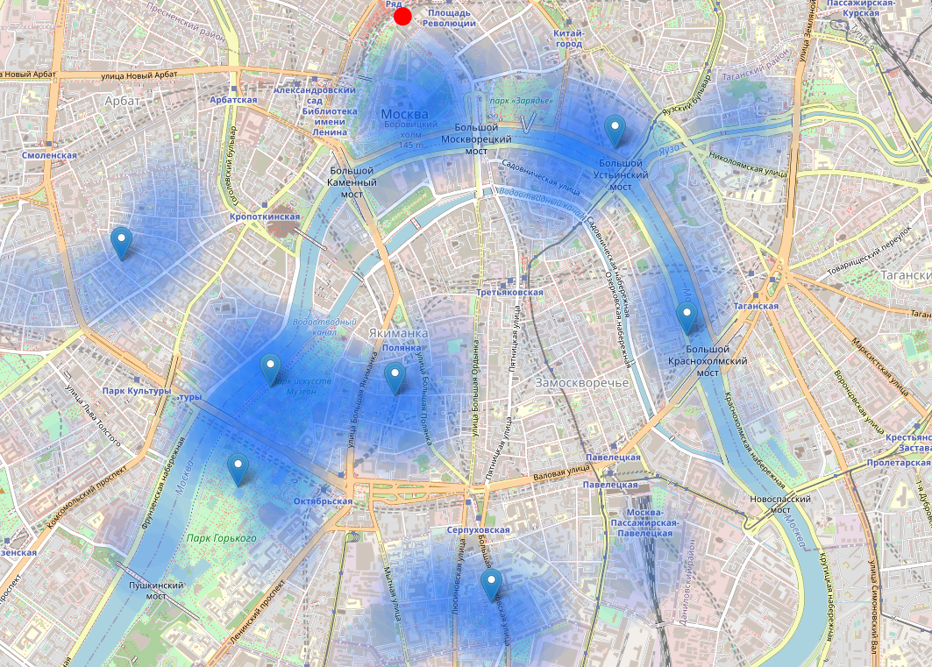

Figure 4 Starting points

1. Results and Discussion

Our analysis shows that although there is a great number of restaurants in Moscow (~1700 in our initial area of interest which was 12x12km around Kremlin), there are pockets of low restaurant density fairly close to city center. Highest concentration of restaurants was detected north and west from Kremlin, so we focused our attention to areas south, south-east and east.

After directing our attention to this more narrow area of interest (covering approx. 5x5km south-east from Kremlin) we first created a dense grid of location candidates (spaced 100m appart); those locations were then filtered so that those with more than two restaurants in radius of 250m and those with an Italian restaurant closer than 400m were removed.

Those location candidates were then clustered to create zones of interest which contain greatest number of location candidates. Addresses of centers of those zones were also generated using reverse geocoding to be used as markers/starting points for more detailed local analysis based on other factors.

Result of all this is 7 zones containing largest number of potential new restaurant locations based on number of and distance to existing venues - both restaurants in general and Italian restaurants particularly. This, of course, does not imply that those zones are actually optimal locations for a new restaurant! Purpose of this analysis was to only provide info on areas close to Moscow center but not crowded with existing restaurants (particularly Italian) - it is entirely possible that there is a very good reason for small number of restaurants in any of those areas, reasons which would make them unsuitable for a new restaurant regardless of lack of competition in the area. Recommended zones should therefore be considered only as a starting point for more detailed analysis which could eventually result in location which has not only no nearby competition but also other factors taken into account and all other relevant conditions met.

1. Conclusion

Purpose of this project was to identify Moscow areas close to center with low number of restaurants (particularly Italian restaurants) in order to aid stakeholders in narrowing down the search for optimal location for a new Italian restaurant. By calculating restaurant density distribution from Foursquare data we have first identified general boroughs that justify further analysis, and then generated extensive collection of locations which satisfy some basic requirements regarding existing nearby restaurants. Clustering of those locations was then performed in order to create major zones of interest (containing greatest number of potential locations) and addresses of those zone centers were created to be used as starting points for final exploration by stakeholders.

Final decission on optimal restaurant location will be made by stakeholders based on specific characteristics of neighborhoods and locations in every recommended zone, taking into consideration additional factors like attractiveness of each location (proximity to park or water), levels of noise / proximity to major roads, real estate availability, prices, social and economic dynamics of every neighborhood etc.